Computing

Useful revision websites | CSNewbs  Key Stage 3 Python | Turtle | CSNewbs
Exam info | Most questions will be multiple choice  The main focus is on setting up the turtle and controlling it  The most challenging questions will need you to type in turtle code

Week beginning | Activity 1 – revision activities  Compulsory | Activity 2 – practice videos  Optional bonus tasks
 | Complete activity 1 – it is a gap fill of key words.  You can complete it online here:  Computing Corsham Countdown activity 1 – Fill in form  Or you can print it and bring it to your lesson | Follow this video and program along with him.  Python Turtle - Code a Square Tutorial  Email a print screen of your work to your teacher  You can program on this website without having to set turtle up on your computer  Python Sandbox | Turtle Mode  Pythonsandbox.com
 | Complete activity 2 – it gets you to calculate angles for different shapes.  You can complete it online here:  Computing Corsham Countdown activity 2 – Fill in form  Or you can print it and bring it to your lesson | Follow this video and program along with him.  Python Turtle - Circle Spirograph Tutorial  Email a print screen of your work to your teacher  You can program on this website without having to set turtle up on your computer  Python Sandbox | Turtle Mode  Pythonsandbox.com
 | Complete activity 3 – it is some questions to show your understanding of code  Computing Corsham Countdown activity 3 – Fill in form  Or you can print it and bring it to your lesson | Follow this video and program along with him.  Python Turtle - Code a Star Tutorial  Email a print screen of your work to your teacher  You can program on this website without having to set turtle up on your computer  Python Sandbox | Turtle Mode  Pythonsandbox.com
 | Complete activity 4 – it is a wordsearch to help you learn the key spellings.  The best way to complete it is to copy it into paint or powerpoint and highlight the answers. Or you can print it and bring it to your lesson. | Follow this video and program along with him.  Python Turtle - Code the Japanese Flag Tutorial  Email a print screen of your work to your teacher  You can program on this website without having to set turtle up on your computer  Python Sandbox | Turtle Mode  Pythonsandbox.com

Activity 1: Fill in the Gaps
Use the words below to complete the sentences.
Word Bank: black, color, turtle, Turtle , Screen, right
- window = turtle.________() creates a drawing screen.
- window.bgcolor("________") sets the background colour to black.
- fletch = turtle.________() creates a turtle object.
- fletch.________("red") changes the turtle's colour.
- fletch.shape("________") makes the cursor look like a turtle.
- fletch.________(90) turns the turtle 90 degrees clockwise.

Activity 2: Calculate the angles
Use the rule:
Angle = 360 ÷ Number of Sides
Shape | Number of Sides | Angle
Triangle | 3 | __________
Square | 4 | __________
Pentagon | 5 | __________
Hexagon | 6 | __________
Octagon | 8 | __________
Decagon | 10 | __________

Activity 3: Answer questions about this code
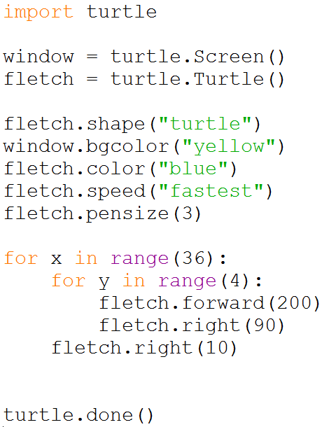
1. What colour is the background?
□ Blue □ Yellow □ Green
2. What colour does the turtle draw with?
□ Red □ Blue □ Black
3. What happens when the turtle does right(90)?
□ Moves forward 90 pixels □ Turns clockwise 90 degrees
□ Turns anticlockwise 90 degrees
4. The turtle moves forward 200 pixels when drawing each square.
□ True □ False
5. How many squares are drawn altogether? __________________

Activity 4: Wordsearch to learn key spellings


