
Subject: French
Useful revision websites | BBC Bitesize
Exam info | Listening, reading and writing

Week beginning | Activity 1 | Activity 2
18th May | Revise Module 1 vocabulary – click the link to use Memrise, create flashcards or practise vocabulary using the worksheets:  - Vocab lists  - Worksheets  (You do not have to complete everything attached. Spend 30 minutes revising) | Use your book to revise Module 1 La Rentrée  - Talking about brothers, sisters and age  - Using the verb avoir  - Describing a classroom  - Talking about likes and dislikes  - Describing yourself and others  - Saying what you do
1st June | Revise Module 2 vocabulary – click the link to use Memrise, create flashcards or practise vocabulary using the worksheets:  - Vocab lists  - Worksheets  (You do not have to complete everything attached. Spend 30 minutes revising) | Use your book to revise Module 2 En Classe  - Saying what you think of your school subjects and why  - Talking about likes and dislikes  - Talking about school uniform  - Your school day  - Saying what there is and isn’t in your school
8th June | Revise Module 3 vocabulary – click the link to use Memrise, create flashcards or practise vocabulary using the worksheets:  - Vocab lists  - Worksheets  (You do not have to complete everything attached. Spend 30 minutes revising) | Use your book to revise Module 3 Mon Temps Libre  - Talking about which sports you play  - Using jouer à  - Talking about activities you do  - Using the verb faire de  - Talking about what you like doing
15th June | Revise Module 4 vocabulary – click the link to use Memrise, create flashcards or practise vocabulary using the worksheets:  - Vocab lists  - Worksheets  (You do not have to complete everything attached. Spend 30 minutes revising) | Use your book to revise Module 4 Ma Vie de Famille  - Describing your family  - Using the possessive adjectives ‘my’ and ‘your’  - Describing where you live  - Talking about breakfast  - Using the partitive article (du / de la / de l' / des)

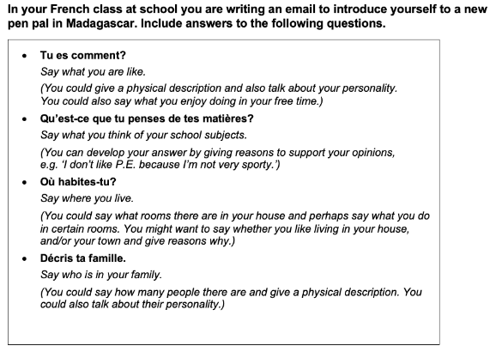
For part of your writing assessment, you will be asked to write a paragraph about the following:

You may prepare this in advance of the assessment.
If you have any questions, please speak to or email your languages teacher/Ms Patton-Hallett.

