Subject: Computing
Useful revision websites | Turinglab - Independent Programming  PowerPoint for the Web - Microsoft 365  Excel for the Web - Microsoft 365
Exam info | 22nd June – 3rd July
Email your teacher a screenshot of any work completed.

Week beginning | Activity 1 | Activity 2
18/5/26 | Online Safety  Watch this video: 11 Internet Safety Tips for Your Online Security  On PowerPoint, make a poster on how you can stay safe online.  - Include a nice title  - Include at least 2 pictures  - Include at least 5 bits of advice, using your own knowledge and from the video you have watched above | Flowchart  Grab a piece of paper and create this flowchart.  - Start - Draw an oval & write start inside it. Draw an arrow coming off of it.  - Decision - Draw a diamond shape below the start. Write this question inside it: Is it raining?  - Decision paths - Draw two arrows coming out of the decision:  - one arrow labelled yes  - one arrow labelled no  - Outputs - Draw a parallelogram at the end of each arrow:  - From yes output: stay inside  - From no output: go outside  Now on your own:  - Add another decision - for example: do I have homework?  - Change the outputs - for example: read a book, play a game, go for a walk

01/06 | Spreadsheet  Create your timetable in Excel. Here is an example:  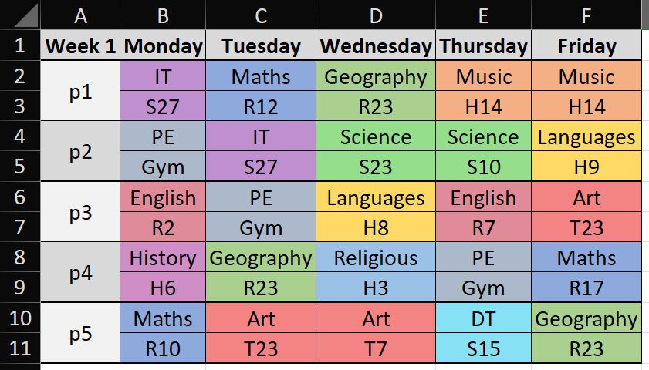  You should make sure to:  - Change column widths  - Add colour to cells  - Add borders to cells | Keyboard Shortcuts  Open this worksheet.  Keyboard Shortcut Quest.docx  Save your own copy by going to File > Create a Copy > Create a copy online.  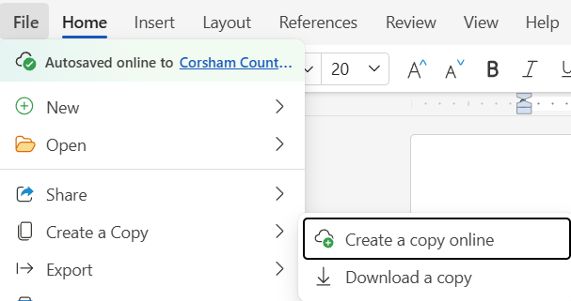  Follow the instructions on the sheet to practice your keyboard shortcuts.
08/06 | PowerPoint  In PowerPoint, can you create a 2 – 3 slide presentation of a school day, including images and some text.  This could include some of:  - Your trip to school  - Tutor time  - lessons  - Break & lunch  - Any clubs  I would like you to add animations to some of the images & text boxes, use these links to help you:  - Animation  - Lesson 4 and 5 - Animation | Spreadsheet  Have a go at answering the questions on the question sheet here:  Corsham Countdown - Spreadsheet Questions.docx  When you are finished, check your answers, writing any corrections in green.  Corsham Countdown - Spreadsheet Answers.docx

