Subject: Art
Useful revision websites | https://hundertwasser.com/en  https://melrye.co.uk/blog/how-to-scale-a-drawing-using-a-grid
Exam info | This will be a skills-based task based on the topic you are currently working on in art.  20 Marks  50 Minutes  Date: Wednesday 10th June

Week beginning | Activity 1 | Activity 2
04.05.26 | Watch these videos on how to use the grid method in art.  How to use a Grid to Draw  Grid Method | Using the grid method, choose an image and use the grid method to help you draw it out.  Download a free drawing grid app to help you!  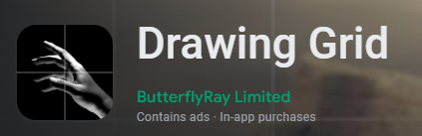  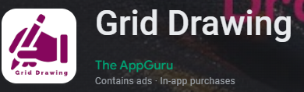  Drawing a Grid using an app
11.05.26 | Watch these videos on different coloured pencil techniques and then have a go at the worksheet.  Coloured Pencil Exercise  Coloured pencil techniques  Coloured Pencil Worksheet.docx
18.05.26 | Watch this video on blending with coloured pencils.  Dos and Don'ts for Blending

