BTEC Digital Information Technology (DIT)
Exam specification  and exam board | Pearson Edexcel  Level 1/Level 2 BTEC
Past paper questions | BTEC DIT Exam Videos – YouTube Links  Past Papers & Exam Questions - SharePoint
Useful revision websites | eRevision – email me if you have not registered  Revision Guide – digital version  Comp 3 Student Book
Exam info | 1st May 2026 – Afternoon  1h 30m  60 Marks
Exam Specification and General Support

You can tick the check boxes to keep track of which tasks you have done if you download/print this document. ☐ ☒
A digital version of your revision guide is available on SharePoint if you don’t have it with you but need to complete homework. Revision Guide
If you would like to reattempt an eRevision task, you can turn on revision mode.
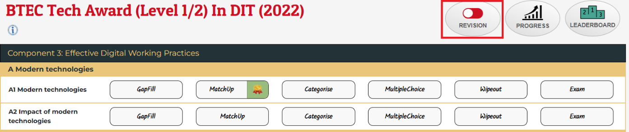
Digital Information Technology
Due  Date: | Activity 1  Compulsory Homework (Thursdays) | Activity 2
Instructions | Using the revision guide:  - Read the pages detailed below  - Answer the questions from the bottom of those pages  - When you finish answering the questions, mark your answers in another colour with corrections  - Complete any unanswered questions using the answers, in a different colour  - Bring in your work to show me on Thursdays  (On paper or digitally)  Additional:  - If you read anything you didn’t remember or had no notes on, add it to your notes | Complete the activities on eRevision listed below, click on My Packages to get there.  Make sure to set your Target Level on the site before you get started.  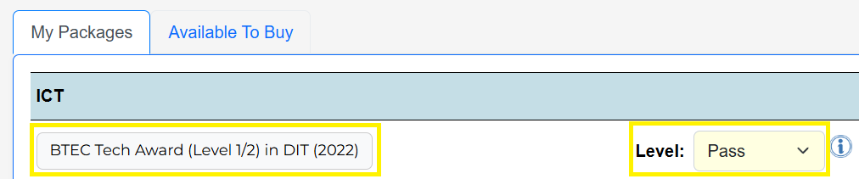  Try and hit the pass mark for each activity below, I can track your progress and give additional credits accordingly.
12/02/2026 | - Collaboration and communication tools ☐  - Scheduling and planning tools ☐  - Communicating with stakeholders ☐  - Choosing communication channels ☐ | A1 Modern technologies:  - Gap Fill ☐  - Match Up ☐  - Categorise ☐  - Multiple Choice ☐
19/02/2026  HT | - Interface design and accessibility ☐  - Impacts of modern technologies on infrastructure ☐  - Impacts of modern technologies on organisations ☐  - Impacts of modern technologies on working practices ☐  Email me your work over half term if you would like. | A2 Impact of modern technologies:  - Gap Fill ☐  - Match Up ☐  - Categorise ☐  - Multiple Choice ☐
26/02/2026 | - Technology and individuals ☐  - Why are systems attacked? ☐  - External threats to digital systems and data security ☐  - More external threats ☐ | A1 Modern technologies:  - Wipeout ☐  - Exam ☐  A2 Impact of modern technologies:  - Wipeout ☐  - Exam ☐
05/03/2026 | - Internal threats to digital systems and data security ☐  - Impact of a security breach ☐  - User access restriction ☐  - User access restriction (continued) ☐ | B1 Threats to data:  - Gap Fill ☐  - Match Up ☐  - Categorise ☐  - Multiple Choice ☐
12/03/2026 | - Firewalls and interface design ☐  - Anti-virus software and device hardening ☐  - Backup, recovery and encryption ☐  - Improving system security ☐ | B2 Prevention and management of threats to data:  - Gap Fill ☐  - Match Up ☐  - Reorder ☐  - Categorise ☐  - Multiple Choice ☐
19/03/2026 | - Who is responsible for security policies? ☐  - Password policy and device hardening ☐  - Software policy ☐  - Disaster recovery policy ☐ | B3 Policy:  - Gap Fill ☐  - Match Up ☐  - Reorder ☐  - Categorise ☐

26/03/2026 | - What to do after an attack ☐  - Sharing data ☐  - Responsible use of shared data ☐  - Environmental impact of technology ☐ | B1 Threats to data:  - Wipeout ☐  - Exam ☐  B2 Prevention and management of threats to data:  - Wipeout ☐  - Exam ☐  B3 Policy:  - Wipeout ☐  - Exam ☐
02/04/2026  Easter | - Reducing the environmental impact ☐  - Equal access ☐  - Professional guidelines and accepted standards ☐  - Net neutrality ☐  Email me your work over the holiday if you would like. | C1 Responsible use:  - Gap Fill ☐  - Categorise ☐  - Multiple Choice ☐
09/04/2026  Easter | - Acceptable use policy ☐  - Monitoring acceptable use policy ☐  - Social and business boundaries ☐  - Data protection principles ☐  Email me your work over the holiday if you would like. | C2 Legal and ethical:  - Gap Fill ☐  - Match Up ☐  - Categorise ☐  - Multiple Choice ☐
16/04/2026 | - Data and the internet ☐  - Intellectual property ☐  - Criminal use of computer systems ☐ | C1 Responsible use:  - Wipeout ☐  - Exam ☐  C2 Legal and ethical:  - Wipeout ☐  - Exam ☐
23/04/2026 | - Data flow diagrams ☐  - Flow charts ☐  - Information flow diagrams ☐  - System diagrams, tables and written information ☐ | D1 Forms of Notation:  - Categorise ☐  - Exam ☐
27/4/26  Exam Week | - Read pg 56 Your Component 3  external assessment  - Read any of the pages 57 – 67 to make sure you understand the different types of questions you will be asked and how to answer them  - Look back through the topics, if there is any page you particularly don’t understand, retry the questions on that page. | - Turn on revision mode and based on the topics you find the most difficult, reattempt those activities
Exam: 1st May 26 - Afternoon

