Computer science

Exam specification and exam board | OCR J277  GCSE (9-1) Computer Science J277 Specification
Past paper questions | GCSE - Computer Science (9-1) - J277 (from 2020) - OCR
Useful revision websites | https://craigndave.org/ocr-gcse-j277-videos/  OCR GCSE Topic List | CSNewbs  eRevision – use your school email to log in
Exam info | J277/01 Computer systems – “paper 1”  90 min Wed 13 May pm  This is the exam that is mostly theory. Your exam notes start with 1. There should be 7 PowerPoints – because 1.2 has 2 parts.  1.1 CPU, 1.2 (part 1) Memory and Storage, 1.2 (part 2) Data representation, 1.3 Networks, 1.4 Network security, 1.5 Software, 1.6 Laws, ethics, etc  J277/02 Computational thinking, algorithms and programming – “paper 2”  90 min Tue 19 May pm  This exam is mostly programming and algorithms. Your exam notes start with 2. There should be 6 PowerPoints – 5 workbooks and your python notes  2.1 Algorithms (remember this has 2 searches, 3 sorts, flowcharts, trace tables and some theory stuff), 2.2 programming (this is your python notes plus the 2.2 workbook we made), 2.3 Robust programs, 2.4 Boolean logic, 2.5 Programming languages and IDEs

Week Beginning | Activity 1 | Activity 2  Email me for the answers
9th February | This is the most important countdown task for paper 1 – finish your essential revision slides for the paper 1 topics we have completed. You should have all your notes on 1 slide.  1.1, 1.2 (2 workbooks), 1.4, 1.5, 1.6  We haven’t done 1.3 yet.  You will have already completed some of them so it is not as massive a job as it might seem. You can do it! | 2.4 Robust programs  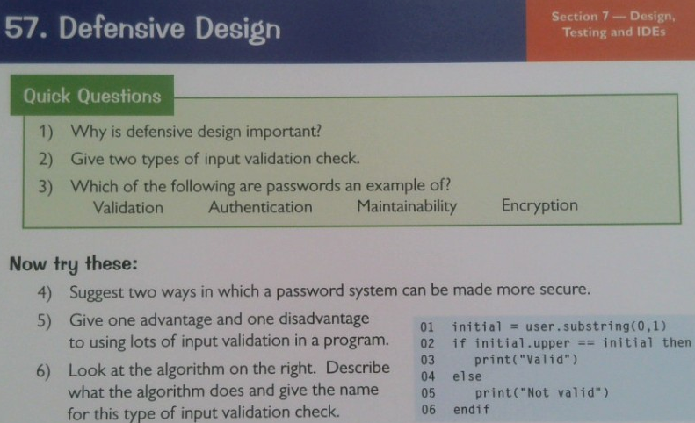
16th February | 1.2 Data representation  Complete pages 25 and 26 from the white question book. Mark and correct your answers in green pen. | 2.2 Programming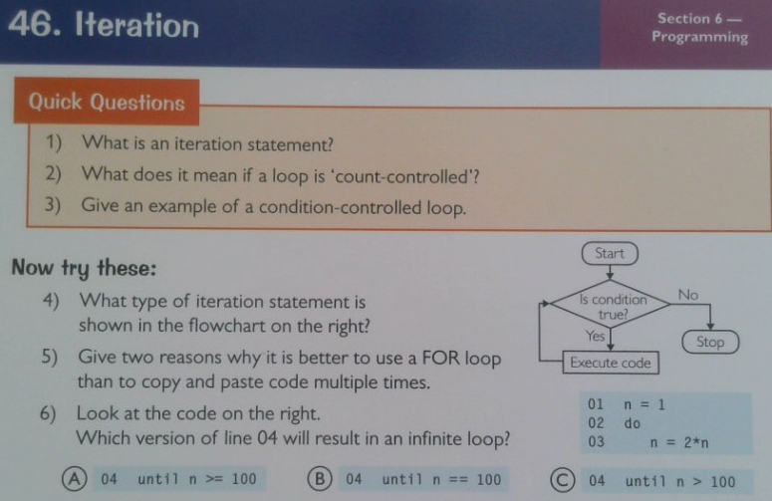
23rd February | 1.1 System Architecture  Complete pages 4, 5, 6 from the white question book. Mark and correct your answers in green pen. | This is the most important countdown task for paper 2 - finish your essential revision slides for the paper 2 topics we have completed. You should have all your notes on 1 slide.  2.1, 2.2, 2.3, 2.4  We wont have done 2.5 yet  You will have already completed some of them so it is not as massive a job as it might seem. You can do it!
2nd March | 1.2 Data representation  Complete pages 16, 17, 19 from the white question book. Mark and correct your answers in green pen. | 2.2 Programming  Complete pages 62 and 63 from the white question book. Mark and correct your answers in green pen.  Bonus – complete page 64 as well (aiming for top grades)

9th March | 1.3 Networks  Complete pages 27, 28 from the white question book. Mark and correct your answers in green pen. | 2.1 Algorithms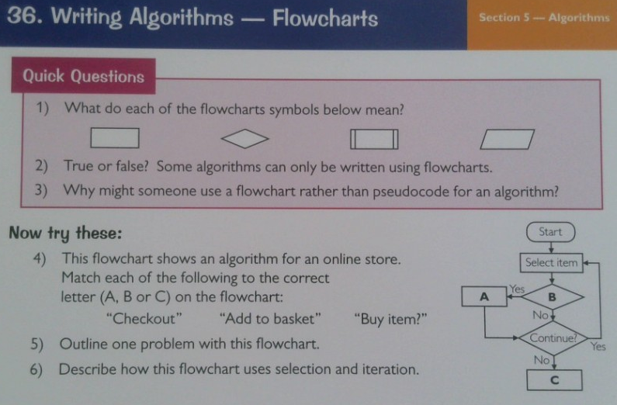
16th March | 1.4 Network security  Complete pages 34, 35, 36 from the white question book. Mark and correct your answers in green pen. | 2.1 Algorithms  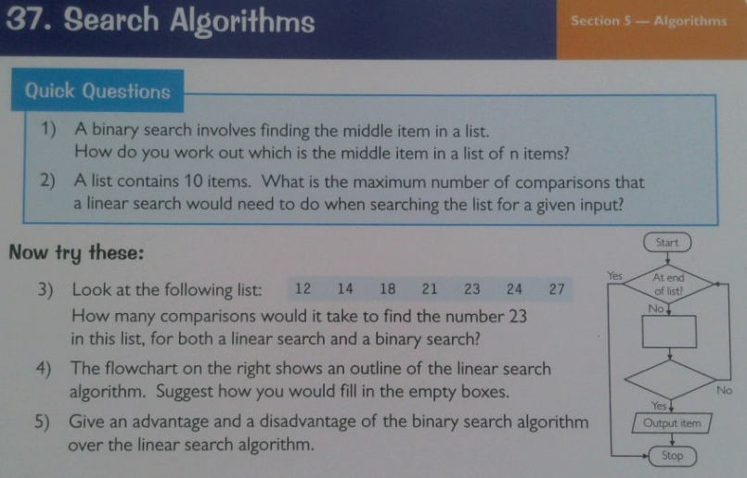
23th March | 1.5 Software  Complete pages 11, 13 from the white question book. Mark and correct your answers in green pen. | 2.1 Algorithms  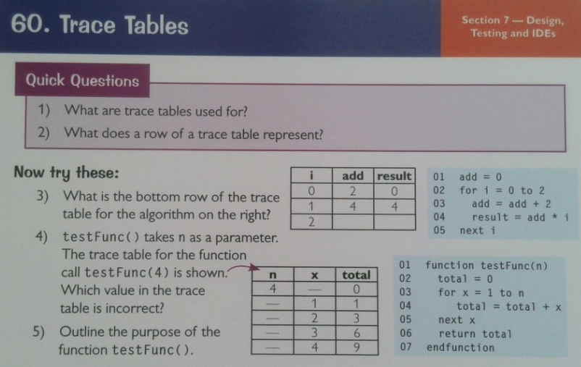
30th March | 1.6 Ethics, legal, etc  Complete pages 40 and 42 from the white question book. Mark and correct your answers in green pen. | 2.2 Programming  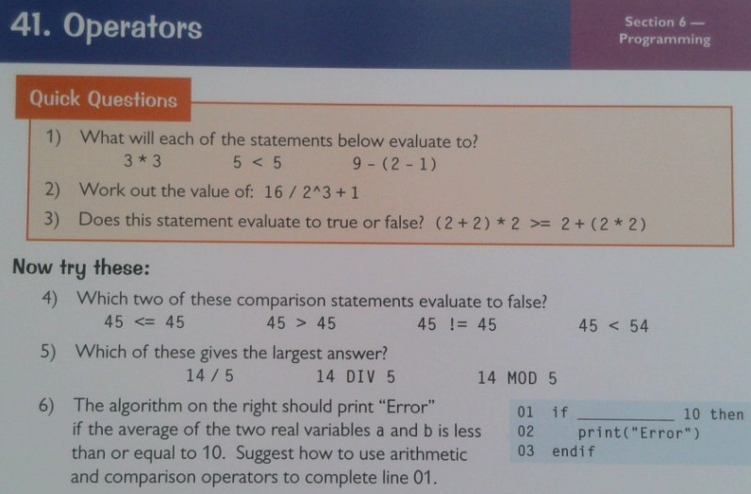
6th April | 2.1 Algorithms  Complete pages 56, 57 from the white question book. Mark and correct your answers in green pen. | 1.3 Networks  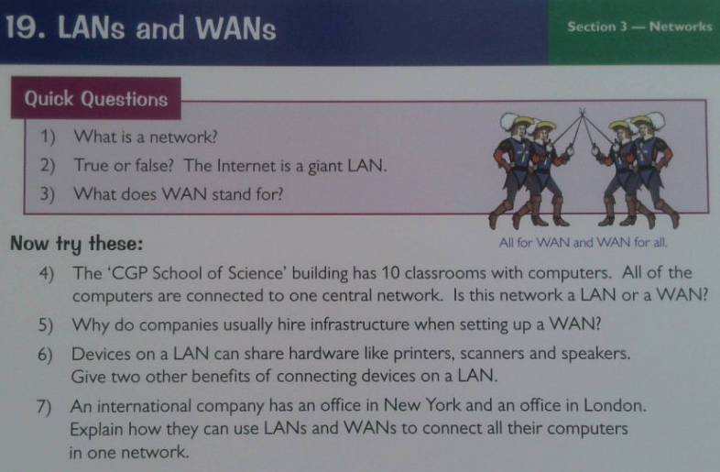

13th April | 2.2 Programming Fundamentals  Complete pages 58, 60 from the white question book. Mark and correct your answers in green pen. | 1.1. CPU  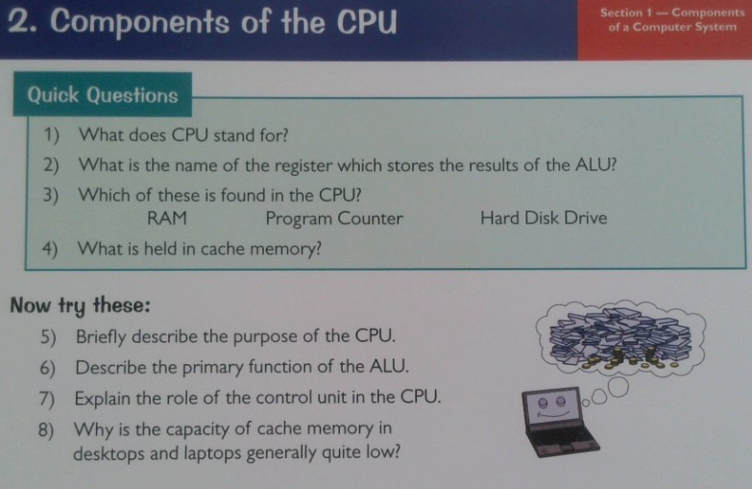
20th April | 2.3 Robust programs  Complete pages 78, 79 from the white question book. Mark and correct your answers in green pen. | 1.2 Data  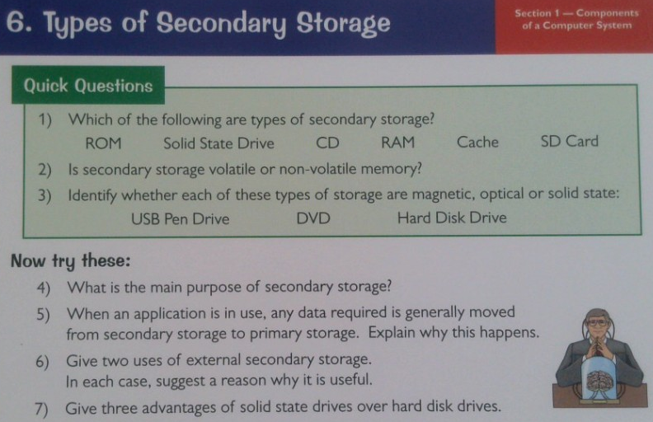
27th April | 2.4 Boolean logic and 2.5 Programming languages and IDE  Complete page 67, 84 from the white question book. Mark and correct your answers in green pen. | 1.5 Software  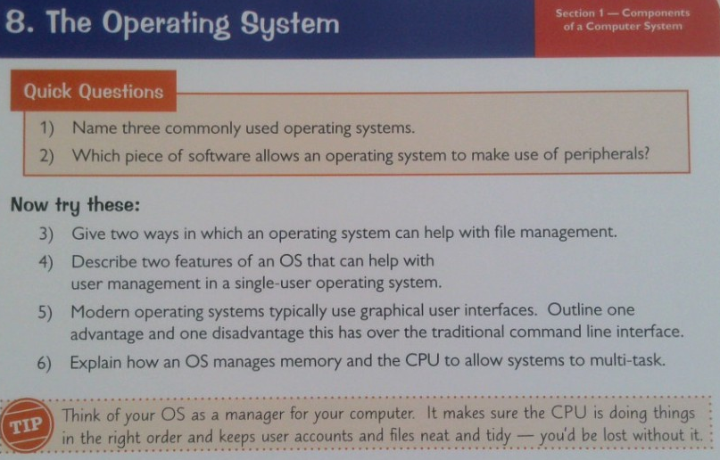
4th May | Past paper exam questions from paper 1. Check your answers against the mark scheme and correct with green pen | Go through all your paper 1 essential revision notes and get someone to quiz you on them
11th May | Past paper exam questions from paper 2. Check your answers against the mark scheme and correct with green pen | Practice programming – make sure you can at least:  Make variables, take inputs, use if-else, repeat using for/while.  Better if you can use procedures and functions, work with arrays.  Best if you can also use 2D arrays, file handing, string handing.

