Subject: Art
Exam info | 40 minutes  20 marks  Drawing Task

Week beginning | Activity 1 | Activity 2
 | Watch these videos on how to use the grid method in art  How to use a Grid to Draw  Grid Method | Using the grid method, choose a food image and use the grid method to help you draw it out. Download a free drawing grid app to help you!  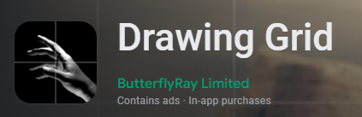  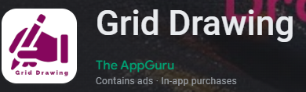  Drawing a Grid using an app
 | Watch this video on how to draw sweets  How to Draw Smarties | Go through the Drawing Technique pages on BBC Bitesize  BBC Bitesize - Drawing Techniques
 | Watch these videos on different coloured pencil techniques and then have a go at the worksheet.  Coloured Pencil Exercise  Coloured pencil techniques  Colour Worksheet | Watch this video on blending with coloured pencils.  Dos and Don'ts for Blending

